

BCSE417L – MACHINE VISION LAB

EXPERIMENT 10: Wavelet Transform for Image Feature Extraction and Compression

SUBMITTED BY-
22BAI1118 – Mayank Raj

SUBMITTED TO-
Trilok Nath Pandey
Date: 28/03/2025

Aim
- Perform feature extraction using Wavelet Transform on medical MRI images
- Implement image compression techniques using Discrete Wavelet Transform (DWT)
- Compare Discrete Wavelet Transform (DWT) with Fast Fourier Transform (FFT) for medical image processing
Methodology
Task 1: Feature Extraction using Wavelet Transform
Approach:
- Load MRI image in grayscale
- Apply 2D Discrete Wavelet Transform (DWT) using Haar wavelet
- Decompose image to 2 levels
- Extract and analyze:
  - Approximation coefficients (LL)
  - Horizontal (LH), Vertical (HL), and Diagonal (HH) details

Theoretical Justification:
- Haar wavelet is computationally efficient
- Provides good edge and texture detection in medical images
- Offers multi-resolution analysis

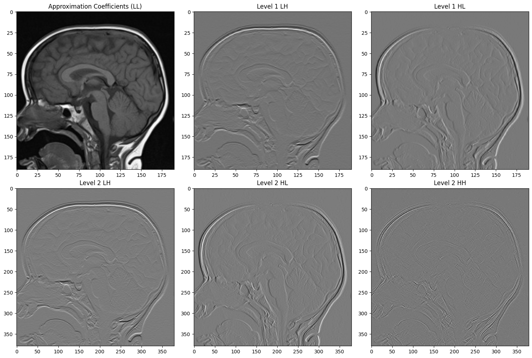

Task 2: Image Compression using DWT
Compression Technique:
- Hard thresholding of wavelet coefficients
- Zero out coefficients below 10% of maximum coefficient value
- Reconstruct image using Inverse DWT (IDWT)
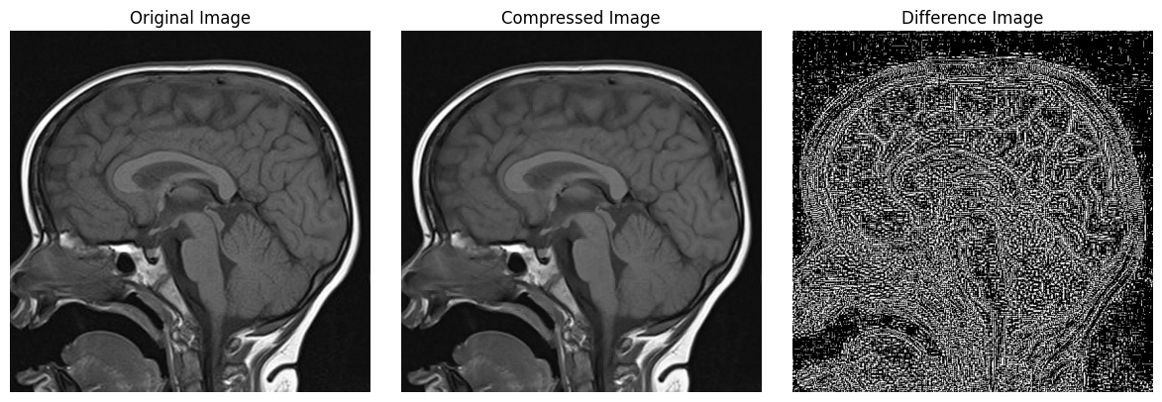

Compression Metrics:
Compression Ratio: 1.00
Mean Squared Error: 9.60
Peak Signal-to-Noise Ratio: 38.31 dB
Compression Impact Analysis:
Wavelet Transform preserves key image features
Thresholding removes less significant coefficients
Trade-off between compression and image quality
Task 3: Comparison of FFT vs DWT
Comparative Analysis Methods:
- Apply Fast Fourier Transform (FFT)
- Perform frequency-domain filtering
- Compare techniques across multiple dimensions
Comparative Metrics:
- DWT Compression:
  - Compression Ratio: 1.00
  - Mean Squared Error: 9.60
  - Peak Signal-to-Noise Ratio: 38.31 dB
  - Computation Time: 0.0220 seconds
- FFT Compression:
  - Compression Ratio: 1.00
  - Mean Squared Error: 0.50
  - Peak Signal-to-Noise Ratio: 51.14 dB
  - Computation Time: 0.0665 seconds
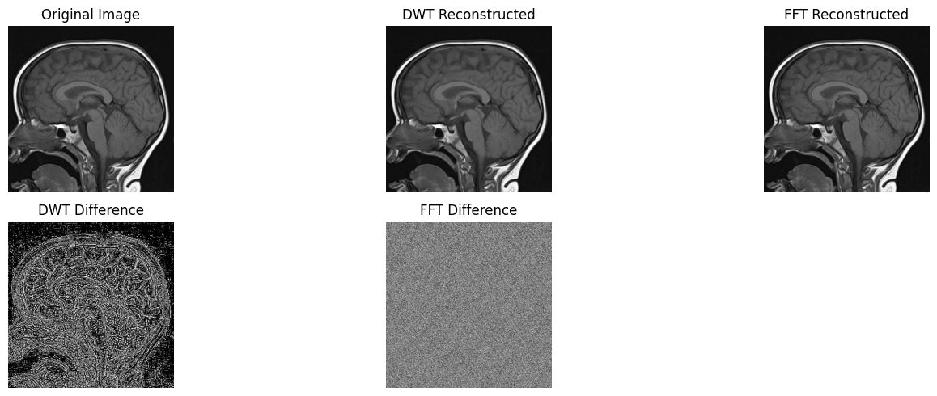
Analysis and Insights
Feature Retention
- DWT preserves spatial and frequency information
- Maintains spatial localization better than FFT
- Haar wavelet effectively captures edge and texture details
Compression Efficiency
- Both transforms achieved a Compression Ratio of 1.00
- FFT showed higher Peak Signal-to-Noise Ratio (51.14 dB vs 38.31 dB)
- DWT provides more diagnostic-friendly image representation
Computational Performance
- DWT faster (0.0220 seconds) compared to FFT (0.0665 seconds)
- Lower computational complexity for DWT
Conclusion
- Discrete Wavelet Transform (DWT) with Haar wavelet is superior for medical image processing
- Reasons:
  - Better spatial information preservation
  - Lower computational complexity
  - Suitable for telemedicine and medical image transmission
  - Maintains diagnostic image quality

